Moose Lake-Windemere Area Sanitary Sewer District
www.mlwssd.org
NEWSLETTER
April 2014
Message from the Sewer District
If April showers bring May flowers, what does April snow bring? A possible late fishing opener …. late start to the baseball season….. and a late construction season. Welcome to Minnesota! That being said if you do have a construction project planned with regards to connecting to our municipal sewer system, please contact us today so that we can get the permit application out to you as soon as possible and the necessary paperwork can be completed before hand. This will help to move the process along much more swiftly.
In the upcoming months the Sewer District will once again be jetting, cleaning and televising some of our lines on the system. This process is done so we are able to inspect the lines to identify any cracks or repairs in the infrastructure. This will help to prevent infiltration and inflow into the municipal sewer system. This process is anticipated to begin in early May. Jetting of the system is done by pushing water through the lines at a high pressure thus removing any debris or sludge left in the system. The Sewer District does not anticipate any interruptions in the service during this process.

A few reminders to folks for the upcoming warmer months and as the spring melt moves on:
- Sump pumps are not allowed to be connected to our system. This is against our Ordinance and could result in a hefty fine.
- Despite what the advertising says, Please Do Not Flush Disposable Wipes down the sewer system whether on our municipal sewer system or on an individual septic system. They cause clogging of pumps and severe maintenance issues. In individual septic systems, they can plug drain fields and the baffles in your tank thus potentially reducing the life span of your septic system and/or causing costly repairs.
- Please keep utility easements open and free from any buildings or obstructions as it is necessary for the District to gain access to the lines from time to time. Before you build or dig on your property please contact our office to make sure that you do not encroach on our easements.

If you need more information, should you need a permit or if you have any questions please contact our office at (218) 485-8276, or by email at mlwssd@mchsi.com . Summer will get here soon, ENJOY IT.
Sincerely,

Darla Hall, Executive Director

NOTICE TO CUSTOMERS
If you would like to receive your newsletter via email rather than by mail, please send your email information and full name to mlwssd@mchsi.com.

Moose Lake-Windemere Sanitary Sewer District Contact nformation
Chairperson, Byron Kuster
4761 Coffee Lake Road
Moose Lake, MN 55767 (218) 485-8511

Vice Chairperson, Cliff Koski
4496 Konieska Road
Moose Lake, MN 55767 (218) 485-8366

Treasurer, Joan Strandlie
94655 Island Lake Road
Sturgeon Lake, MN 55783 (218) 485-8868

Board Member, Henry Gretsfeld
93672 Sunbay Lane
Sturgeon Lake, MN 55783 (218) 485-4869

Board Member, Dean Paulson
4845 Riverside Road So.
Moose Lake, MN 55767 (218) 485-0298

Executive Director, Darla Hall
MLWSSD (218) 485-8276
mlwssd@mchsi.com
Superintendent
Keith Newman
(cell) 218-380-6114

Office Hours Mon., Tues., Wed. 8:30 a.m. to 2:30 p.m.

Inside This Issue
1 | Message from the District
2 | Information You May Not Know about Lateral Lines
3 | Water Conservation Tips
4 | Dye Test for Checking Toilet Leaks

Information You May Not Know about Lateral Lines

A Guide to Your Private Sewer Service Line
The Moose Lake Windemere Area Sanitary Sewer District has been serving some of our original customers since the late 70’s early 80’s. We continuously monitor and repair our municipal sewer system, however, the line that runs from your home or building to the municipal sewer system is the homeowner’s responsibility to maintain. Property owners can and should be proactive with inspecting, maintaining and replacing their lateral lines before they fail. Waiting until these pipes fail before fixing or replacing them can be untimely, more expensive and could cause damage to your residence and/or property.

What is a lateral line?
The lateral line connects your home or building to the municipal sewer system. Wastewater from your sinks, showers, toilets, dishwashers and washing machines flows through the lateral line to the municipal sewer system. The connection point of the lateral line and the municipal sewer system is sometimes referred to as the “point of service” which is basically where your connection meets the Sewer District’s main line in the street or right of way.

Who is responsible for maintaining and repairing the lateral line?
The lateral line is private property. It is the property owners' responsibility to maintain and repair the lateral line. It’s important to keep the lateral line clear of obstructions and in good working order. This will greatly reduce the risk of blockages, clogs and water backups.

What causes lateral lines to become blocked or obstructed?
Lateral lines can be blocked or obstructed by items flushed down the toilet or washed down the drain, as well as tree roots, vegetation roots, poor installation practices, grease, and other obstructions.

How do I know if my lateral line is blocked or damaged?
Some signs that your lateral line is blocked or damaged include slow draining, water pooling around the basement floor drains, sewage smell inside or outside the building, wastewater leaking from cleanouts, and wet ground in your yard.

Will insurance cover repairs to the lateral line?
Most homeowners'/business owners' insurance policies do not cover damages caused by a problem with the lateral line. You should verify coverage with your insurance agent.

How do I maintain the lateral line?
- Have the lateral line inspected and cleaned by a licensed plumber. Make sure the contractor is licensed, bonded and is qualified to perform the work.
- Do not plant trees or large shrubs near the lateral line. Roots can enter the lateral line and cause a blockage. If roots enter your lateral line, call a licensed plumber to clear the line.
- Do not pour grease down the sink. When grease cools, it can build up in the lateral line and cause a blockage.
- Do not flush diapers, disposable wipes, feminine hygiene products or other non toilet paper materials down the toilet. These items can block the lateral line.
- Repair or replace damaged lateral lines as soon as possible.

Water Conservation Tips
Practicing conservation requires a change in behavior. What we save today will have an impact on our children tomorrow. From turning off the faucet while brushing your teeth to taking showers instead of baths, these simple daily changes can help save our natural resources and protect our environment for the future. From our lakes and streams to fish and wildlife, water is no more a luxury of plenty. Education plays a vital role in conservation. Did you know.....Installing restrictive shower and faucet heads can save up to 50% of water used? .....In the average home, 2/3 of all water used indoors is used in the bathroom?.....Toilets use 33% of that indoor usage?..... Please use the following tips to help you do your part to conserve water :
Lawn Care:
- When mowing, use a mulching blade and leave grass clippings on your lawn. Grass clippings contain water and nitrogen which help keep your lawn green.
- Water only when needed. Most lawns need only one inch of water per week to stay healthy even during the hottest summer months.
- Water in the early morning to minimize evaporation and allow the water to soak to the roots.
- Do not water when it is windy out.
- Aerate your lawn in the spring to help loosen the soil and allow water to soak to the roots of the grass more easily.
- Use a sprinkler system that has a timer to better monitor your watering.
Garden Care:
- Use plants that do not require much watering during the summer.
- Use mulch in your soil around your plants. 1"-2" of mulch will help moisture stay in the soil and allow you to water less often.
- Water slowly enough to allow water to soak into the soil and not create run-off.
- Set sprinklers to water only areas you want watered. Avoid watering sidewalks and driveways.
Indoor Care:
- Use flow restrictive shower and faucet heads.
- Turn your faucet off while shaving and brushing your teeth.
- Check for leaks in all your faucets and toilets. Repair as necessary.
- Replace your old toilet with a new water efficient model. Older model toilets use 5-7 gallons per flush. New low consumption toilets use 1.6 gallons per flush.
- Use full loads in your dishwasher and washing machine. 1/2 loads use just as much water as a full load with only half the benefit.
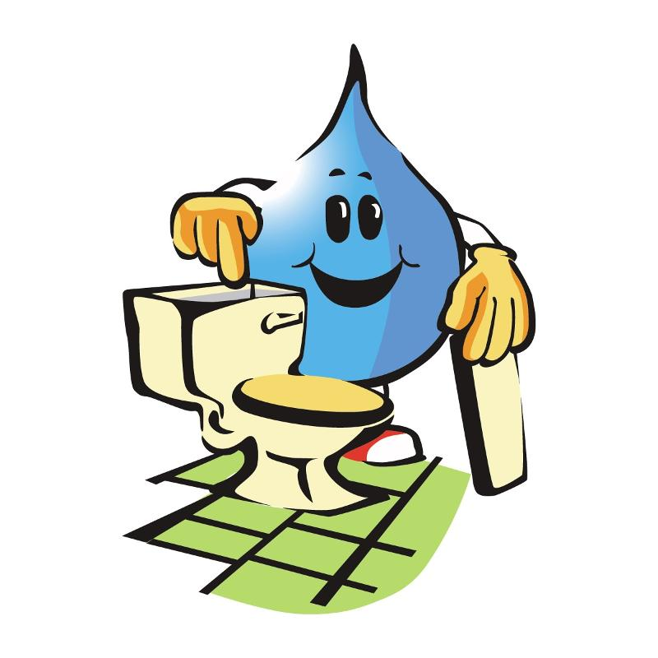
Miscellaneous:
- Use a broom to clean off driveways and sidewalks, not your hose.
- Use a hose with a shut-off nozzle to wash your car.
Did You Know:
- An average leaky faucet can lose as much as 2000 gallons a year.
- A leaky toilet can lose up to 200 gallons a day.
- Leaving your water running while brushing your teeth wastes 5 gallons per minute.
- 50%-70% of household water is used outside to water lawns and gardens.
- Only 1% of the world’s water is drinkable.
- A person can live about a month without food, but only about a week without water.
Checking a Toilet for Leaks
Unknown water use is most often the result of a leaking toilet. Sometimes toilet leaks aren’t seen or heard. It is a good idea to check for a leaking toilet at least once a year.

- Remove the TANK lid.
- Put 5 – 10 drops of food coloring in the TANK. Put the lid back on but don’t flush it yet.
- After about 10 minutes, look in the BOWL. If you see color, you have a leak.

The main causes of a leak are either a “fill valve” that will not shut off or a bad “flapper”.
Fill Valve Problem
A fill valve problem will cause water to flow over the “overflow tube”, either because the water level is set too high or it won’t shut the water off. If you can’t adjust the water level lower or can’t get the fill valve to shut off, replace the fill valve. Pedestal fill valves are considered more reliable than the ball and float type.
Bad Flapper
If you had water run into the bowl during the dye test and the water level is not set too high, your flapper is probably leaking and it should be replaced. If your old flapper has a float on the chain, make sure your new one does too (or put the old float on the new chain). When replacing a toilet flapper, remember that it is very important to replace it with the proper flapper model for your toilet. Using a standard flapper in many 1.6 gallon toilets can make the toilet flush up to 3.5 gallons per flush (except Flush Star models).

MLWSSD  Moose Lake – Windemere Sanitary Sewer District  304 ½ Elm Avenue PO Box 588  Moose Lake, MN 55767 |  | Third Class  US Postage  Paid  Moose Lake, MN 55767  Permit No. #73

